Creating Custom VPC:-

Step1:- Created VPC with IPv4 CIDR block:- 10.0.0.0/16  
  
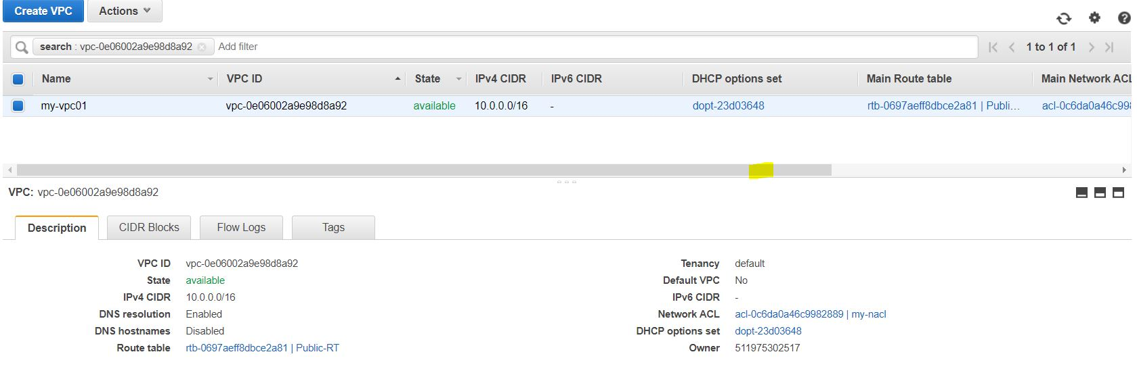

After creating VPC we need to create one Public and one Private Subnet in the VPC created.

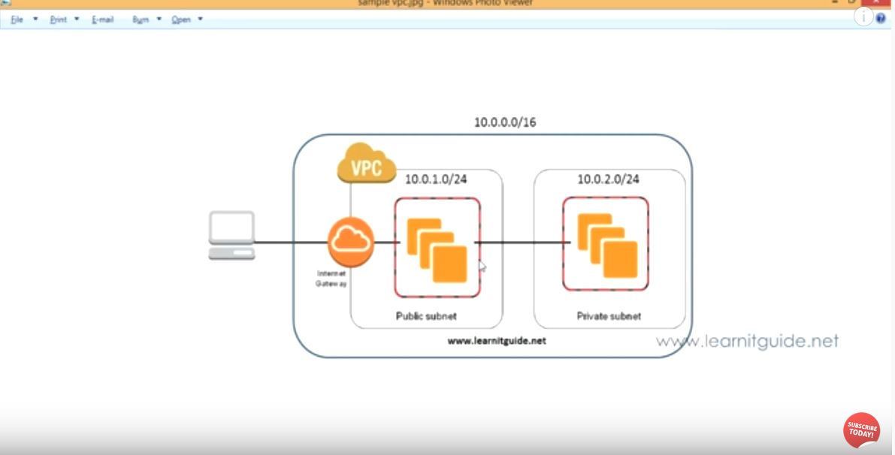

Step2:- Created attached one Private and Public Subnets in different availability zone and attached to VPC created.



Step3:- Created Internet Gateway and attached to VPC created.



Step4:- Created one Windows EC2 instance and placed it in Public Subnet.

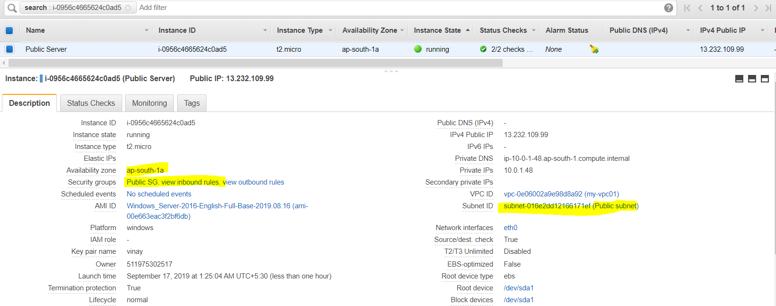

Step5:- Logged into the windows server using Remote Desktop file with Decrypted password and then

Choose Server Manager Dashboard -> Add Roles and Feautures -> Role-based/feauture-based installation -> WebServerIIS -> Click Install.

Then File Storage and Server groups will be created which looks as below.

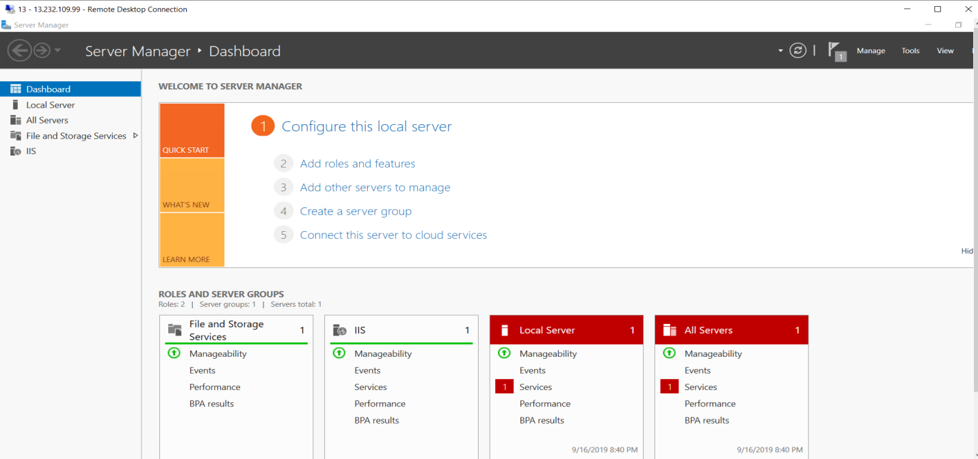

Step6:- To test whether localhost is working or not. Please paste <http://localhost> on browser.

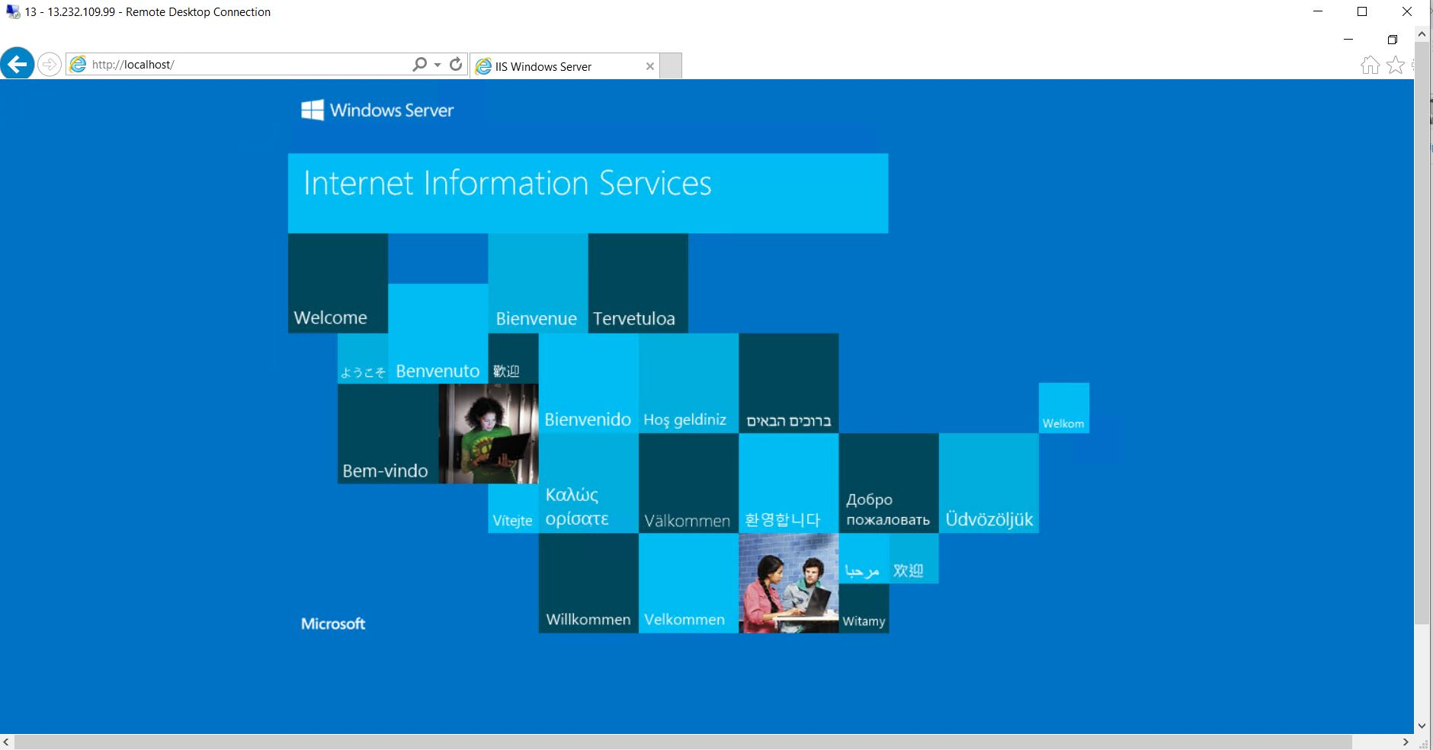

Step7:- To launch one sample website, I copied one file to C:\inetpub\wwwroot/index.html and pasted the URL:- <http://localhost/index.html>

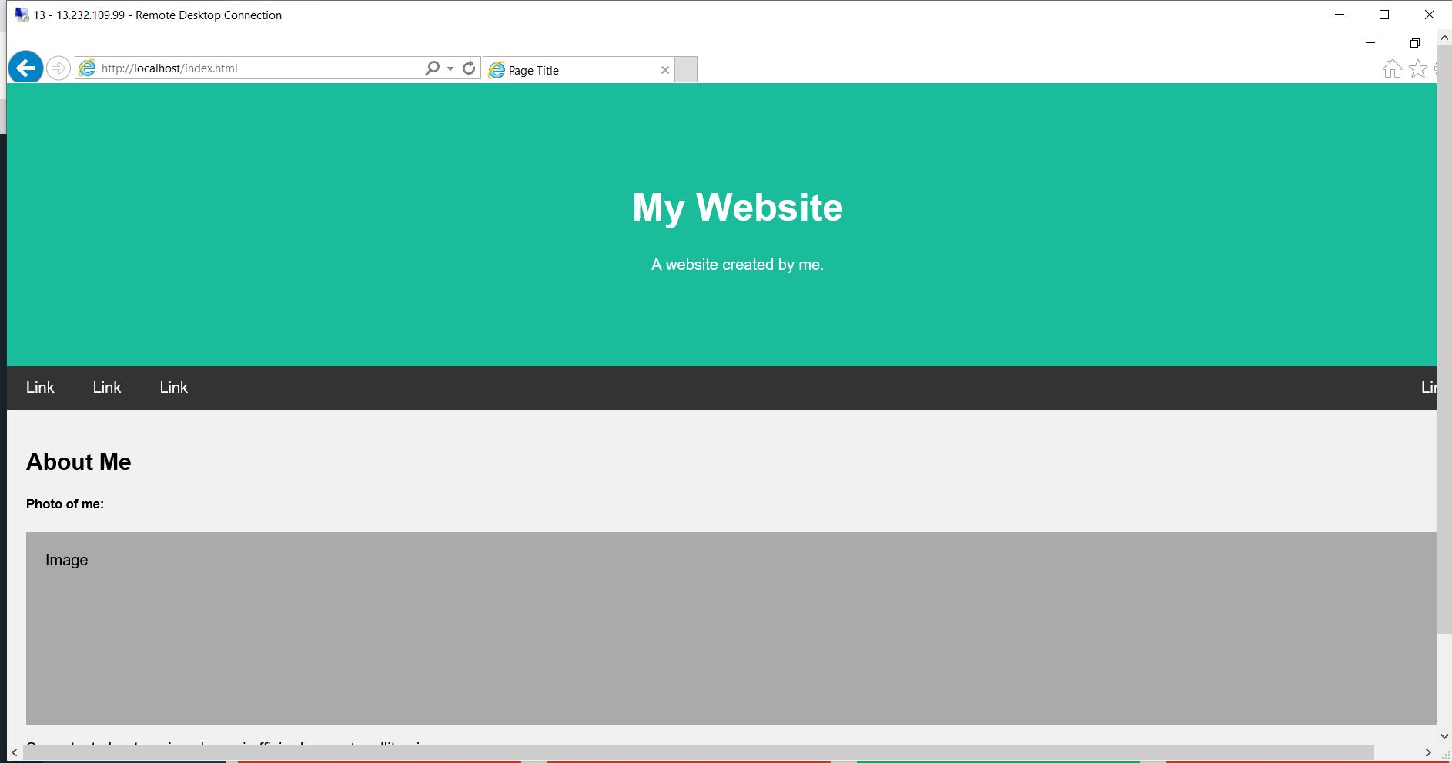

Step 9:- To enable port bindings, we need to go to Windows Administrative tools -> IIS Server Manager and then perform the below operation.

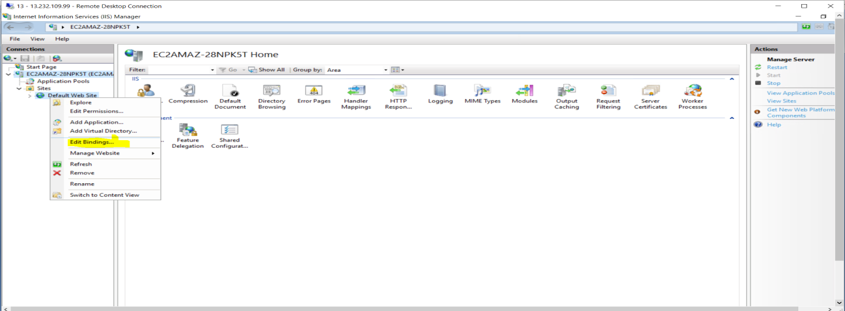

After clicking small pop-up window will appear, there you need to replace with the port number 80 with 8080. Then paste <http://localhost:8080>. Here we will same website on different port number.

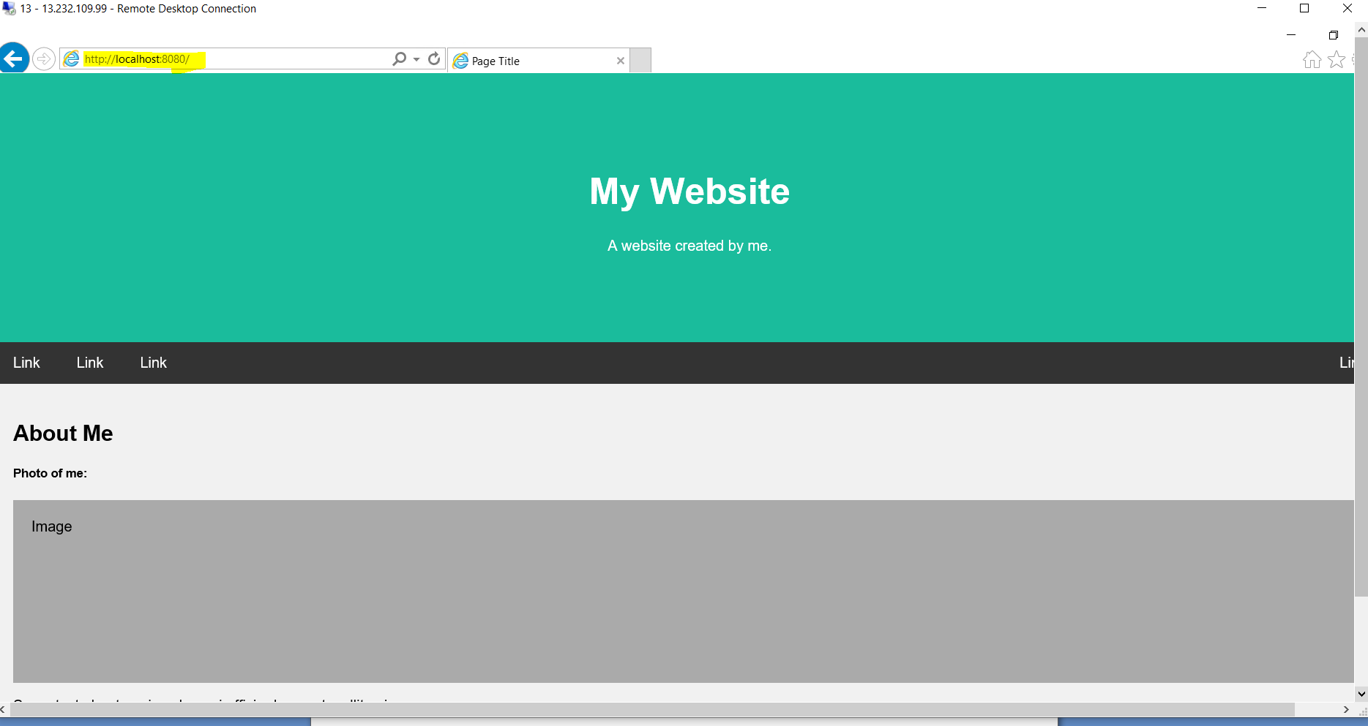

* **To configure FTP Server and connect by creating user:-**

Step1:- Got to Server Dashboard and Add role-based/feauture installation, Select Service FTP Serever under Webserver-IIS.

Then go to Computer Management and Add Group and also add users to that group. We will create FTP group and add FTP users in that group.

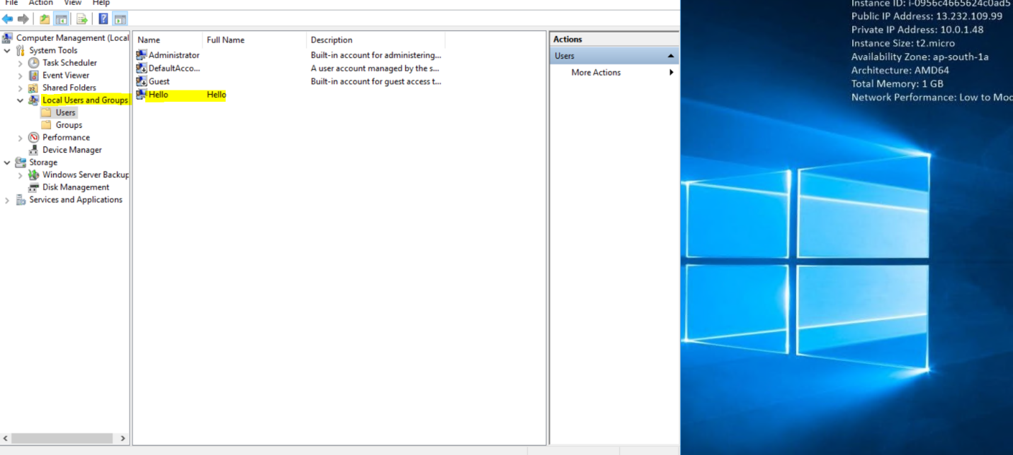

Step2;- Go to IIS Manager and Click on hostname and Create an FTP site and Select path where you will create one file called FTP .

Note :- I am facing error over here where I am not able to see the FTP site option.